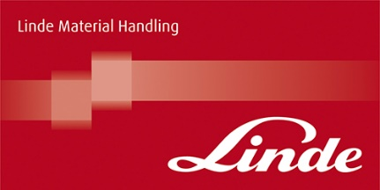

To enable us to maximise your learning, we would be grateful if you could complete this form and return it to your Stewart at the start of your next training session.

Course Title: | Consultative Selling Skills
Name:
Job title:
How would you describe a consultative approach to selling?
How does a consultative approach to selling differ from other approaches to selling?
What aspects of your MTD Sales Insight Assessment link to a Consultative approach to selling?
What are your main objectives for the Consultative Selling Skills Course?

